Zoom Meeting
Library Volunteer Manager Peers - Notes
5/27/20, 1:30 EST
Host: Wendy Johnson, Indianapolis Public Library
wjohnson@indypl.org

Bess is right! I need a timekeeper. I can’t help it. I love hearing all of your ideas and just lose track of time. Thank you everyone for sharing!

Next gathering: Wednesday, June 3, 2020 at 1:30EST
Zoom: https://us02web.zoom.us/j/85000048095

We will NOT be gathering on Wednesday, June 10th in favor of those of us attending the Points of Light Conference. FREE. Register here: https://web.cvent.com/event/bd001afe-0cea-4b22-ab54-32e56a04f185/summary.

Take care!

Wendy

Topics Discussed

How many staff are allowed in the building at a time?
- 14 in our large branch, 3 in our smaller neighborhood branch
- No rule, but staff have been divided up into teams that can’t cross teams
- 32 since we came back with 5-6 volunteers. All came back at the same time
- Branch libraries have no staff; at the Main branch about 8 staff
- Not open yet, most likely in the next 2 weeks
- Looking at square footage to figure out how many staff with a 6 feet around them
- Basing decision on County Health’s guidelines and SqF. Planning a M/W/F team and a T/Th/Sat team.
- All staff in – keeping distance and wearing masks. Break room is open with distancing at lunch.
- Masks, announcing entrance to stairwells while keeping 6’ apart. One person in elevator. No patrons in building, but offering curbside by appt only for 8 or 28 branches
- Small staff, 6 per weekday and 3 on weekends. Masks, distancing. Break rooms are closed or 1 in room at a time. No curbside yet.
- The big issue that is being discussed is how to roll out curb side/returning items. We don't want to overwhelm the five big libraries, since the smaller ones won't have capacity to receive large amounts of books and of course no place to quarantine the items.
- Want to have volunteers come in at same time as staff: five working internet sales and one with donation processing.
Virtual Training (for volunteers)
- Tools being used:
  - Drupal – slides, questions, admin can access who has finished
  - Niche Academy – offers some testing too
  - Class Marker
  - Videos added to YouTube channel
  - PowerPoint
  - A volunteer created a game – putting books in order
- Ways that virtual training is being used:
  - Putting books in order – this helped reduce time staff were training volunteers. Plus volunteers could review at any time.
  - General volunteer orientation
  - Preview what volunteering looks like before they come in for an interview/orientation
  - Shelving basics
Volunteer Orientations/Interviews
- Quarterly in groups with PowerPoint
- Small group to review things that are common things for all roles and the handbook. Then volunteer goes into the field for specific training. Also emergency procedures.
- Volunteer coordinator at the branch conducts volunteer interview, scheduling, and training
- eHarmony for volunteers. A match maker connecting potential volunteers to opportunities throughout the system
Adopt-a-Shelf opportunity
(Please send any Adopt-a-Shelf descriptions to Carla – clehn@califa.org)
- A shelf is one shelf unit or more depending on the time the volunteer has to give
- Great for students with hour requirement who need a flexible schedule
- Family volunteer opportunity: One adult with at least one youth (min age 6)
- Tasks include: dusting shelf, shelf reading, book display, blocking, offering book review for a title on their shelf
- Place name on shelf
- Students have a contest for most books from display taken
- Ask for once a week or once every-other week commitment. Have more time? Then adopt more shelves.
- Decorate shelf for holiday
- Track the number of books shelved/out-of-place as part of monthly/annual numbers
Job Coach/Supported Workers
- Consider what the goal is for the volunteer: motor skills, learning to navigate transportation, basic job experience (showing up on time, signing in/out), etc.? Talk to the coach before the interview.
- Treat coach as a full volunteer too – meaning all screening is done, track their hours
- Coach must be present at all times
- Tasks dependent on ability: Adopt-a-shelf, sort DVDs, straighten periodicals, restock bus route carousel, clean DVDs, library steward (cleaning covers in kid section, dusting), assembling craft kits
- Clear that this is not a guarantee of a job
- Example: Partnership with Community Transitions program. High School graduates between ages 18-21. A small group comes 3-4x/wk throughout the school year for 1.5 hours before the library opens. Shelving juvenile DVDs (maybe adult DVDs at times). Teacher/supervisor stays with the group and checks their work. At the end of the year they all receive a certificate and bit Thank you!
- Example: We have special volunteers from Easter Seals of San Pedro, CA. They come in once a week for one hour and they straighten the book shelves and collect books that are left on the tables.

Volunteer Coordinator/Staff Training
(Please send Stephanie any materials that you might have, she’s rewriting hers. Stephanie.truax@austintexas.gov)
- People who will managing the branch volunteers receive a 90 min to 120 min orientation
- Mandatory training
- One 3 hr training yearly, coaching upon request
- We sit with them through their first (and second) volunteer interview
- Two training sessions a year – Volunteer Engagement Mini-Retreat – 3 LEUs. Focus is on a particular topic: Hosting a Group, Pet Therapy program, Recognition ideas, Staff Buy-in, etc. Most valued is the group sharing time offering new ideas and troubleshooting volunteer issues. We tap some of our local volunteer coordinators to come in as the Expert speaker.
- Branch Volunteer Coordinator position description

Staff Buy-in (we should talk more about this)
- Attend managers’ meetings to build trust
- Find an ally, successfully engage volunteers with them, ask for them to “talk it up”
- It’s a slow build

Miscellaneous
- Volunteer time commitment: Various, but generally 6 months. Think about the ROI for bringing in a volunteer vs. the time that they give.
- Virtual volunteer opportunity – Closed caption transcription for posted videos
- Background checks in public spaces – only for 1:1; all volunteers regardless of public or behind the scenes. Product: LiveScan. Only for volunteers 18 and up.
Resources
- Documentation samples: https://getinvolvedclearinghouse.org — Click on Management Tools, then select keyword: Volunteer Handbooks
Conversation Starters
- COVID times
  - Introducing volunteers back into system
  - Virtual/Remote Volunteering. Policies, procedures, roles, etc.
  - When will volunteers return to the branch? What will they be doing?
- Best Practices and General Topics
  - Staff buy-in
  - Homebound program volunteer safety guidelines (Kate K.)
  - Volunteer Management Software – Jessica, when’s the next Volgistics User Group?
  - How are you measuring volunteer impact?

Shelf Reading Procedure
Courtesy of The Library/ Dauphin County Library System
- To read a shelf start at top shelf and read each shelf left to right to the bottom shelf. When you reach the bottom right side of the shelf, then continue reading at the top left of the connecting shelf. Figure 1 illustrates the process.
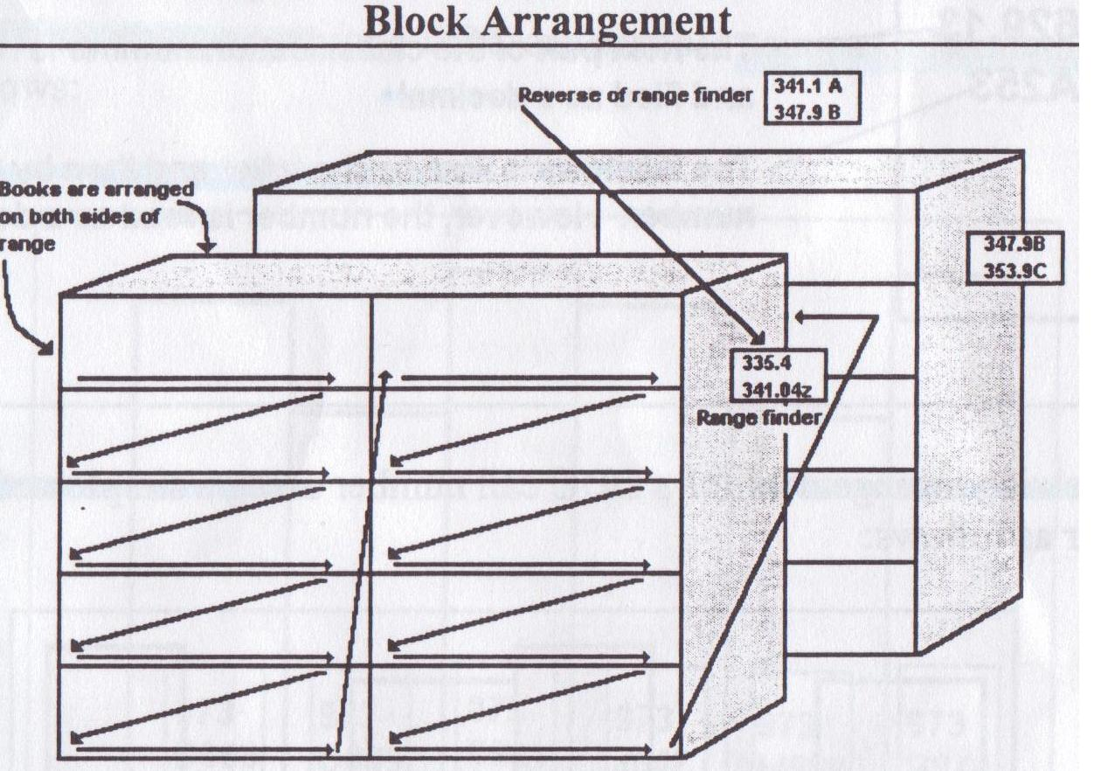
Fig. 1. (Living In the Library World, 2009)

- You follow the order of the spine labels on the shelf.
- Hint: You may touch each label as you check the spine label. This will help you keep track of the books you already shelf read.
- If an item is not in order, then pull off the shelf and give the item to a staff member to be checked-in.
- Be sure to check behind the books and down at the bottom of the shelves for items which may have slipped out of place. These should also be given to a staff member to check in.

- Straighten the books and slide them to the left side of the shelf will keep the shelf looking neat and tidy. Make sure books ends are against materials to the most appealing look to the shelf.

- Books should be to the front edge on a shelf.

- If possible, shelves should only be 2/3 full. If one shelf is filled to the edge and the next is only 1/3 full, then while keeping materials in perfect order, move the items to the next shelf. The result is two shelves that look neat and inviting.

Shelf Reading Hints
Courtesy of The Library/ Dauphin County Library System
- For numerical success, remember number order.
  - 641.5 before 641.52 before 641.524
  - Books with the same number are shelved in alphabetical order
613.042 before 613.042
Hea Nul

- For alphabetical success:
  - The words “A”, “An”, and “The” do not count in alphabetizing when those words are the first word in a title. Shelve using the second word.
  - Numbers in the beginning of a title come before letters.
  - Hyphenated names by the first part of the last name such as Garcia-Roza.
  - “Mac” comes before “Mc”

- When grasping a book, do not tug it from the top of the spine. It is best to get a full-on grasp of the book from the middle of the spine and cover. Tugging a book from the top weakens the top of the spine and may cause breaking or tattering at the top of the spine.

- Shelves should look neat and inviting. Front-face displayed books should be current, visual appealing and seasonal (if appropriate).

- Those who shelve materials and shelf read resemble tortoises: Accuracy rules over speed!

