Volunteer
Onboarding Checklist
Name: | Library Name |  | Start Date:
Supervisor: | Volunteer Dates and Times
Thank you for volunteering with the Metropolitan Library System!
The Library is comprised of nineteen library branches spread throughout Oklahoma County and the numerous departments that support their operations. The Library is governed by a 27-member Library Commission, representing every community that receives library services in the county. Our operating budget is collected from ad valorem property taxes, and supports the cost of personnel, materials, support (of facilities and staff), and capital improvements. Since 2012, the Library has opened or undertaken major renovations of several locations and fostered massive growth of digital resources to meet the evolving needs of our guests.

Thank you for volunteering with the Metropolitan Library System. We appreciate your support and dedication to help serve the community through our mission and core values.

MLS Mission
Connecting our diverse communities with resources and experiences to educate and enrich lives.

MLS Core Values
Equity, Diversity and Inclusion; People First; Innovation; Integrity; Respect
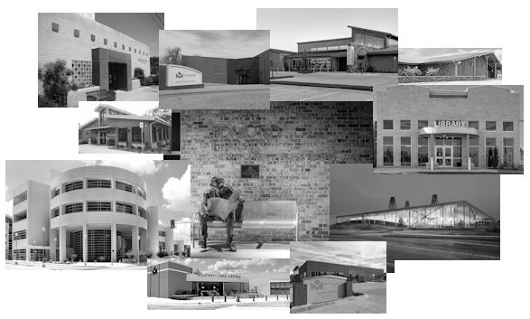

Day 1 – All Volunteer Positions
Volunteer Initial & Date |  |  |  |  | Supervisor Initial
 | Welcome, introductions, and thank you!
 | Library Tour: emergency exits, workroom, restrooms
 | Workspaces, Lockers, Personal space
 | Local Attendance Procedures – Calling in
 | Dress Code
 | Rules of Conduct/Security/PITS/Safe Place
 | Volunteer Hours Tracking
 | Severe Weather, Tornado, Fire and Other Emergency Procedures
 | Volunteer Position Overview
 | Guest Service Expectations
 | Do they have a library card? Offer to sign up
 | Overview of Metropolitan Library System
 | Value of Volunteer and Tasks
 | Review Confidentiality and the Freedom to Read
Day 1 – Adopt a Shelf
 |  | Introduction to shelf straightening and shelf-reading
 |  | Complete Collection Scavenger Hunt
 |  | Review Shelving Order Guide and Local Shelving Order
 |  | Demonstration and practice of inventory
 |  | Tour of volunteer’s collection
 |  | How to pick books for in-shelf displays
 |  | How to look for lost items / quirks of searching for lost items
 |  | Demonstrate cleaning procedures (Clorox wipes and Swiffer Duster)
Review Goals:
- Complete inventory of section within 5 volunteer hours
- Create a list of recommendations from volunteer's collection (5-10 books)
- Be able to select materials for in-shelf displays
- Complete lost list within 5 sessions
Day 1 – Shelving
 |  | Introduction to shelf straightening and shelf-reading
 |  | Complete Collection Scavenger Hunt
 |  | Review Shelving Order Guide and Local Shelving Order
 |  | Complete Niche Academy Shelving Orientation
 |  | Complete Niche Academy Shelving Training
 |  | How to pick books for in-shelf displays
Review Goals:
- Shelve materials
- Be able to select materials for in-shelf displays
Day 1 – Tech Helper
 |  |  | Tour of Public computer software
 |  |  | Computer Settings Navigation
 |  |  | Explore all print options
 |  |  | Use Self-Checkout machines
 |  |  | Go over Troubleshooting guide
 |  |  | Discuss technical/legal disclaimers
 |  |  | Difficult Interactions
 |  |  | Shadow info desk for examples of troubleshooting
Review Goals:
- Share a success story with a staff member
- Develop the volunteer's teaching/helping philosophy - How do they try to go about tech help?
- Successfully assist three guests during a volunteer period
- Learn each method of printing
Day 1 – All Volunteers, End of First Shift
 |  |  | Thoughts on first day?
 |  |  | Confirm time/date of next shift
 |  |  | Thank you!
Day 2 – Adopt a Shelf
 |  | Complete Day 1 Tasks as needed
 |  | Collection Scavenger Hunt Review
 |  | Q&A on Local Shelving Order
 |  | Attempt first inventory, review how it went
Day 2 – Shelving
 |  | Complete Day 1 Tasks as needed
 |  | Collection Scavenger Hunt Review
 |  | Q&A on Local Shelving Order and Shelving Order
 |  | Begin independent assessment of sections shelving
 |  | Shelve
Day 2 – Tech Helper
 |  |  | Complete Day 1 Tasks as needed
 |  |  | Hands on experience with self-check machines, printing, copying, faxing
 |  |  | Review guest interactions
Note: there is a “Damage and Pest Training – Volunteer" PowerPoint in the Volunteer Supervisor SharePoint under “Toolkits”. This is for volunteers that will be handling material.
Glossary of Terms
Access – Access is a division of service within the Public Services division that is primarily responsible for the day-to-day operations of the library and ensuring Access to customers. Access tasks involve checking materials in and out, creating library accounts, resolving customer fines and other account issues, shelving materials, and ensuring the collection is accurately organized and easy to browse.
Catalog (OPAC) – The Online Public Access Catalog (OPAC) is what customers can use to browse our collection online, place holds, and manage their library account.
Engagement – Engagement is the other division (along with Access) of service with the Public Services division. Engagement staff handle engaging with customers both inside the library and within the community. They plan and conduct programs, perform reader’s advisory, and handle in-depth reference questions.
Public Services – the division of Metro that includes the libraries, CIS, and Access, which coordinates the day-to-day front-line services libraries provide to the public.

