The Beginner’s Guide to Identifying First Editions, Part One

By Amanda Nelson

https://bookriot.com/2012/11/08/the-beginners-guide-to-identifying-first-editions-part-one/
Like many things in publishing, what denotes a first edition can be complex and dependent on the whims of each publishing house. Each company does their first edition identification (if they do any at all) differently, so unless you’ve got a handy-dandy house-by-house guide, the whole concept can make you go a bit cross-eyed. But there are a few very basic rules that can be helpful–and keep in mind these are for the person who has never examined a copyright page and is new to analyzing what editions they have. I’m going to use some books from around my house to illustrate:
“First Edition” Means Different Things to Different People
TO THE PUBLISHER
A FIRST EDITION is the first version of a book before changes are made (forewords added, afterwards added, typos corrected, whatever requires a new typeset).
SECOND PRINTING, FIRST EDITION: If the publisher prints 5,000 copies of a book, they all sell, and the publisher goes back to print more of the same version of the book? That is a second printing, first edition. The copyright page may even still say “First Edition” on it somewhere.
TO BOOKSELLERS AND COLLECTORS
A FIRST EDITION is both the first typeset version of the book AND the first printing. If the publisher sells out of the first run and goes back for another printing, that second printing is not considered a true first edition, even if the copyright page says it is. An easy way to tell a bookseller is trying to get one over on you is if they try to sell you a later-than-first printing and call it a “first edition.”
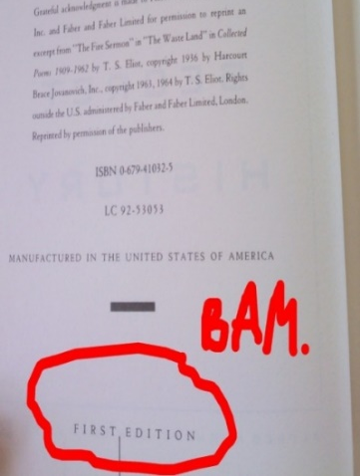
STEPS TO IDENTIFYING A FIRST EDITION
STEP 1: Does it say “First Edition” on the copyright page? Exhibit A, the copyright page of my first edition of The Secret History.

What if there is no “first edition on the copyright page?
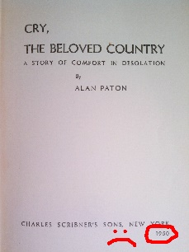
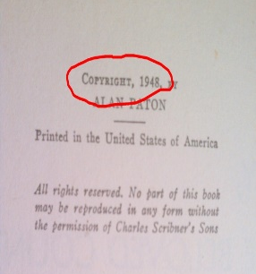
Check the title page for a publication date and compare it to the date on the copyright page.

STEP 2: Check For Printings
So, if a book has had more than one printing, how can you tell which one you have and therefore whether or not your edition is a “true” first? This one really depends on the publisher.
THE SMALL PUBLISHING HOUSE - If it’s from a small press, which often runs only one printing of a book, you’re usually safe assuming what you have is a first edition unless otherwise noted.
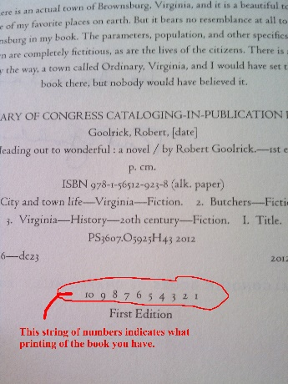
THE LARGE PUBLISHING HOUSE - With many of the larger publishing houses, you’re on the lookout for a string of numbers on the copyright page, as shown in this copy of Heading Out to Wonderful.
The string of numbers can be descending, as it is here, ascending, or in totally random order.
To identify what printing you have, look for the lowest number in the string. In this example, the lowest number is 1, so I have a first edition, first printing. Remember that even if the lowest number is 2, 3, or whatever, if the publisher is still using the original typeset, then the copyright page may still say “First Edition.”
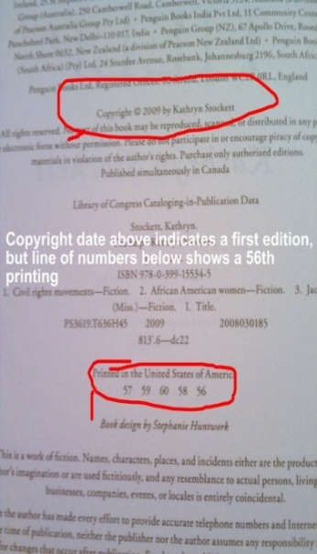
If the copyright page does not say what edition you have but still has that string of numbers, check the date on the page. Look up the original publication date of the book to see if it matches. If the string of numbers has a one in it and the copyright page date matches the publication date, you’ve probably got a first printing of the first edition, though you should check this guide to see what the specific publisher usually does.
Here’s an example from my copy of The Help, where the absence of a date other than the copyright date indicates it might be a first edition, but the string of printing numbers tells us that it is not a “true” first edition:
That wraps up part one of The Beginner’s Guide to Identifying First Editions. In the next post, we’ll be talking about how to handle slightly more difficult first edition problems: internationally published books, book club editions (which are often identical to the actual first edition), etc.

More clarification from Abe Books
Identifying the First Edition of a Book
Identifying a first edition is no simple matter. There are thousands of publishers and they use a large variety of methods, which are often changed, to define first editions.
The publisher may actually state the words ‘first edition’ or ‘first printing’ on the copyright page. Another common method of identification is the number line – that’s a line of numbers on the copyright page. Usually, if a one is present in the line then it’s a first edition. This style has been used since World War II.
The line sequence could ascend or descend or even have no discernable order depending on the publisher. All of these sequences below are first editions.
1 2 3 4 5 6 7 8 9 10
10 9 8 7 6 5 4 3 2 1
1 3 5 7 9 10 8 6 4 2
(All first editions)
Sometimes the number line is also accompanied by the words ‘first edition’, but be careful because some publishers leave on the words ‘first edition’ even when the book is in its third printing and that fact is reflected in the three in this number line.
First edition
3 4 5 6 7 8 9 10
(Third printing)
This number line below identifies a second printing printed in 1975.
75 76 77 78 79 10 9 8 7 6 5 4 3 2
If you find that the date on the copyright page matches the date on the title page, then it is probably a first edition. Most 19th century publishers placed the date of publication on the title page but that practice faded out after 1900 and the date became appearing on the copyright page.
Some publishers make no statement at all about first editions but booksellers learn to identify firsts by other methods – for instance a particular piece of copy on the dust jacket or a mistake in the book’s text itself that is corrected in later editions.

