**Get Involved Library Benefits Worksheet**

Library _____________________________________________________________________________

Person Completing this Form Name: ____________________________ Email: ___________________

**MEASURING VOLUNTEER VALUE**

# Library Volunteer Hours this Year ____________ Increase Over Previous Year? No___ Yes___ %___

# of Volunteer Hours x Value of Volunteer Hour* ($38.61 for CA in 2023) = $ ____________________

*\** [*https://independentsector.org/wp-content/uploads/2024/04/is-vovt-report-all-years_v2-1.pdf*](https://independentsector.org/wp-content/uploads/2024/04/is-vovt-report-all-years_v2-1.pdf)

Return On Investment (ROI): *(You can get a worksheet here:* [*http://volpro.net/volunteer-roi/*](http://volpro.net/volunteer-roi/)*)*

1. Calculate Program Costs: List and total all costs for your volunteer engagement service, including but not limited to: staff time assigned (remember, if it’s 25% of a full-time person, use just 25% of the salary); staff benefits (again, based on % time of staff assigned); office supplies; travel costs; training; recognition expenses; etc.
2. Calculate Volunteer Value: Take the volunteer hours (total) for the year and multiply by the value of volunteer time figure (above).
3. Calculate ROI: Subtract Program Costs from Volunteer Value, then divide that by the Program Costs. (ROI = (volunteer value – program cost) / program cost. *(i.e., for every dollar invested in the volunteer program, $______ was returned)*

**HOW WE INVOLVE VOLUNTEERS – SUCCESS STORIES**

**We use volunteers in the following positions at the library:**

**Our favorite story about how library volunteers make a difference in the community is**:

**Our best example of a skilled volunteer position is:**

**Without volunteers, the following library services/programs would be decreased or lost:**

**Engaging volunteers for the library is important to us because: *(check all that apply)***

___ They get work done

___ They bring specialized skills

___ They help us expand or enhance programs

___ Frees up staff time to do other things

___ Helps us gain community connections

___ They bring new energy and ideas

___ They often become strong library supporters

___ They become donors

___ Other: ______________________________

____________________________________

**HOW WE ORGANIZE OUR VOLUNTEER RECRUITMENT**

Our Library has our Central Library and ___ # Branches

Our Library uses ___# VolunteerMatch Accounts (20-mile radius search for each account)

If the state library stopped paying for our VolunteerMatch accounts, our library would pay for them. *($99 per year per account)* ___ Yes ___ No ___ Not Sure

Our library manages its volunteer recruitment like this: (check all that apply)

___ All volunteer referrals go to one central person or office

___ Each Branch does its own recruitment

___ Individual Departments do their own recruitment (i.e., Teen Services, Literacy, etc.)

___ We also help with recruitment for Library Friends and/or Foundation

___ We have volunteers who help with various aspects of the volunteer engagement program.

(Examples?)

**Other notes/thoughts to share for library director statement of support for volunteer engagement?**

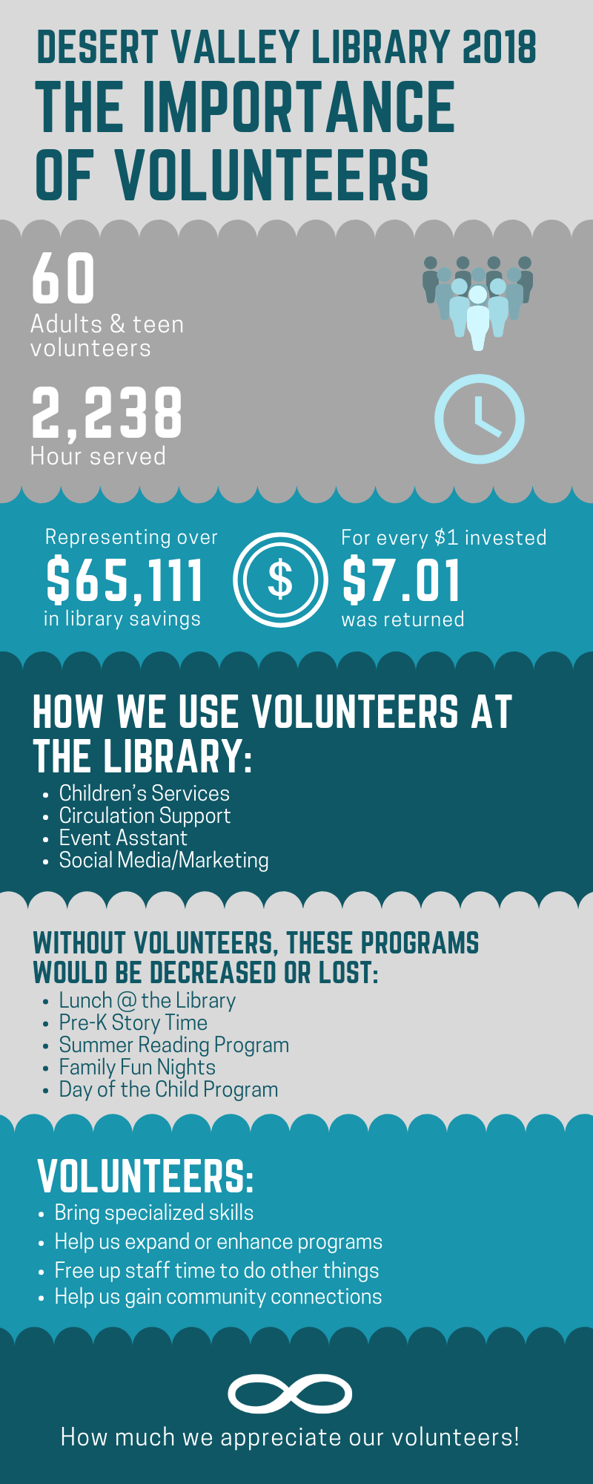**Sample infographic**